Name: Apurba Koirala
22BCE3799
Deep Learning Lab Assessment 3
Guided by: Dr. Sharmila C
- Perform object detection using Transfer Learning with a pre-trained CNN architecture (e.g., VGG16, ResNet, or InceptionNet). Fine-tune the selected model on any dataset and evaluate its performance.

from tensorflow.keras.datasets import cifar10
(x_train, y_train), (x_test, y_test) = cifar10.load_data()
from tensorflow.keras.utils import to_categorical

x_train = x_train.astype('float32') / 255.0
x_test = x_test.astype('float32') / 255.0
y_train = to_categorical(y_train, 10)
y_test = to_categorical(y_test, 10)

from tensorflow.keras.applications import VGG16

base_model = VGG16(weights='imagenet', include_top=False, input_shape=(32, 32, 3))
base_model.trainable = False

for layer in base_model.layers[-4:]:
layer.trainable = True

from tensorflow.keras import layers, models

model = models.Sequential([
base_model,
layers.Flatten(),
layers.Dense(256, activation='relu'),
layers.Dropout(0.5),
layers.Dense(10, activation='softmax')
])

from tensorflow.keras.optimizers import Adam
model.compile(optimizer=Adam(learning_rate=0.0001),
loss='categorical_crossentropy',
metrics=['accuracy'])

history = model.fit(x_train, y_train,
validation_data=(x_test, y_test),
epochs=10,
batch_size=64)

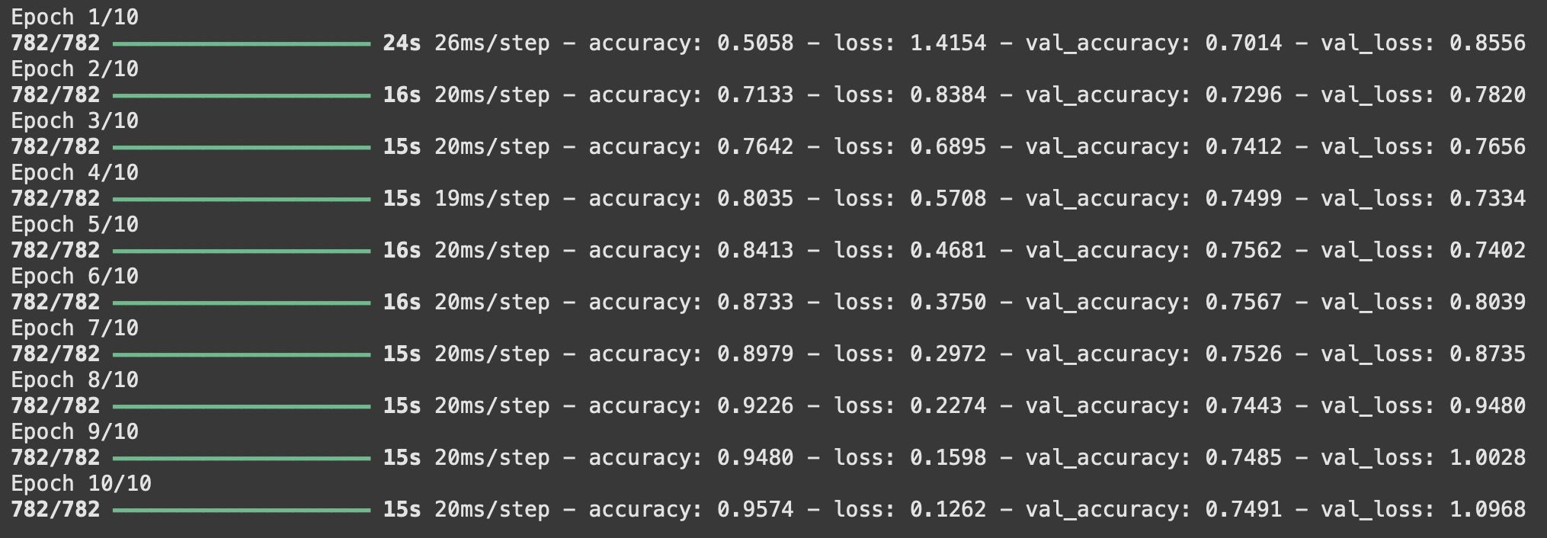

test_loss, test_acc = model.evaluate(x_test, y_test, verbose=0)
print(f"Test Accuracy: {test_acc:.4f}")
class_names = ['airplane', 'automobile', 'bird', 'cat', 'deer', 'dog', 'frog', 'horse', 'ship', 'truck']

num_images = 10
indices = np.random.choice(len(x_test), num_images, replace=False)
sample_images = x_test[indices]
sample_labels = y_test[indices]

predictions = model.predict(sample_images)

plt.figure(figsize=(15, 5))
for i in range(num_images):
plt.subplot(2, 5, i + 1)
plt.imshow(sample_images[i])
true_label = class_names[np.argmax(sample_labels[i])]
predicted_label = class_names[np.argmax(predictions[i])]
plt.title(f"Predicted: {predicted_label}\nTrue: {true_label}", fontsize=10)
plt.axis('off')
plt.show()
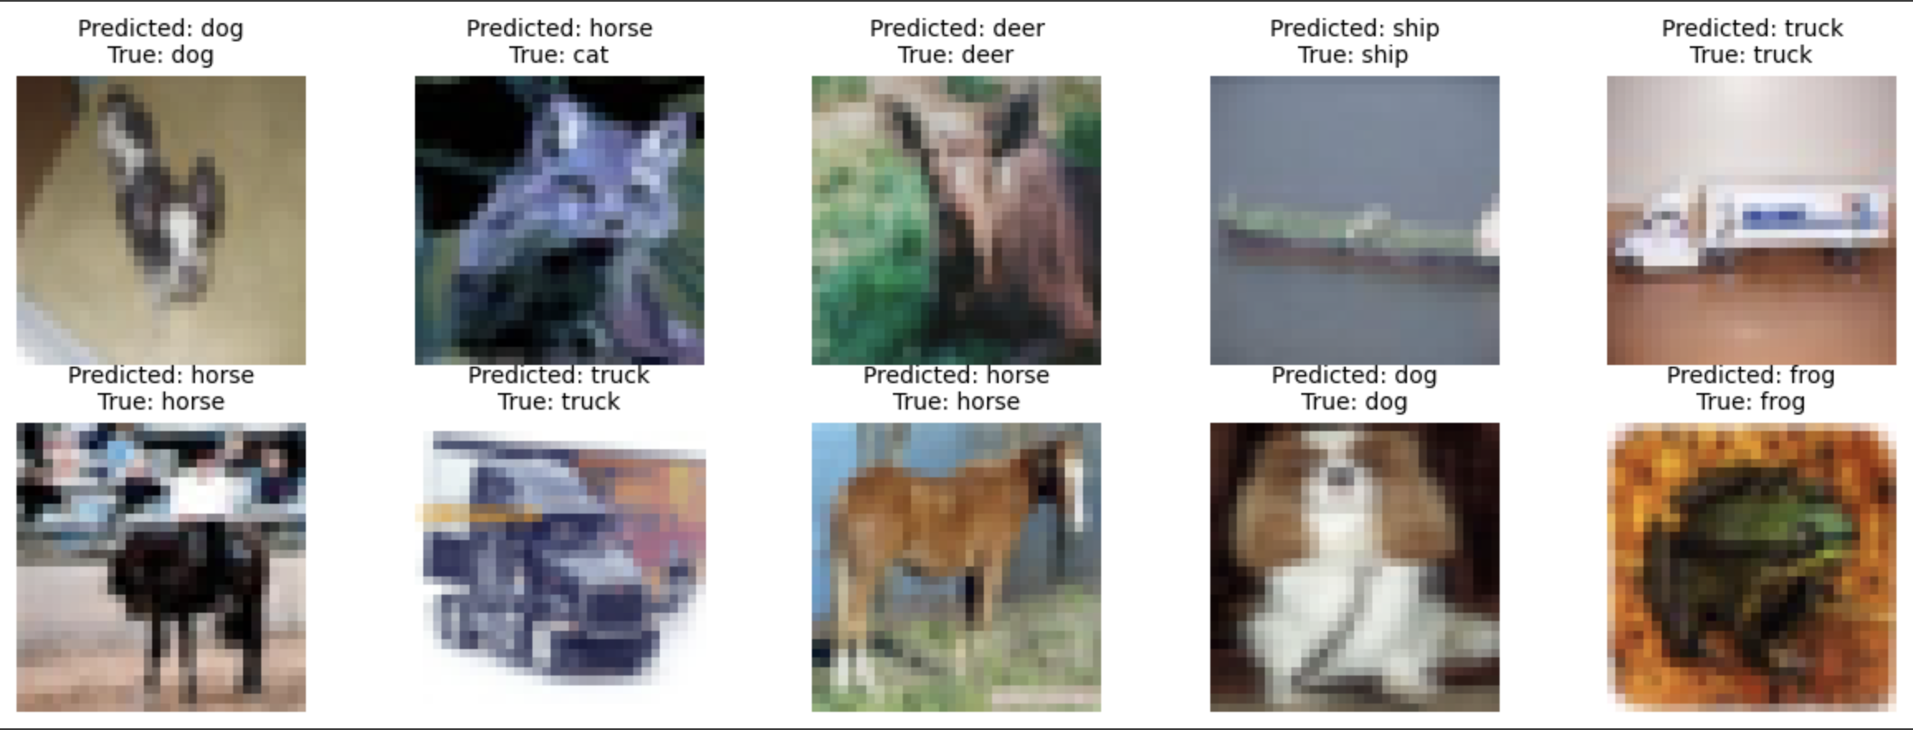

- Implement an Autoencoder for image denoising using the CIFAR-10 dataset. Add Gaussian noise to the input images and train the autoencoder to reconstruct clean images. Evaluate the performance by visualizing the original, noisy and reconstructed images.

(x_train, y_train), (x_test, y_test) = cifar10.load_data()
x_train = x_train.astype("float32") / 255.0
x_test = x_test.astype("float32") / 255.0

noise_factor = 0.3
x_train_noisy = x_train + noise_factor * np.random.normal(loc=0.0, scale=1.0, size=x_train.shape)
x_test_noisy = x_test + noise_factor * np.random.normal(loc=0.0, scale=1.0, size=x_test.shape)
x_train_noisy = np.clip(x_train_noisy, 0., 1.)
x_test_noisy = np.clip(x_test_noisy, 0., 1.)

from tensorflow.keras import layers, models

input_img = layers.Input(shape=(32, 32, 3))
x = layers.Conv2D(32, (3, 3), activation="relu", padding="same")(input_img)
x = layers.MaxPooling2D((2, 2), padding="same")(x)
x = layers.Conv2D(64, (3, 3), activation="relu", padding="same")(x)
encoded = layers.MaxPooling2D((2, 2), padding="same")(x)
x = layers.Conv2D(64, (3, 3), activation="relu", padding="same")(encoded)
x = layers.UpSampling2D((2, 2))(x)
x = layers.Conv2D(32, (3, 3), activation="relu", padding="same")(x)
x = layers.UpSampling2D((2, 2))(x)
decoded = layers.Conv2D(3, (3, 3), activation="sigmoid", padding="same")(x)

autoencoder = models.Model(input_img, decoded)
autoencoder.compile(optimizer="adam", loss="mse")
autoencoder.summary()
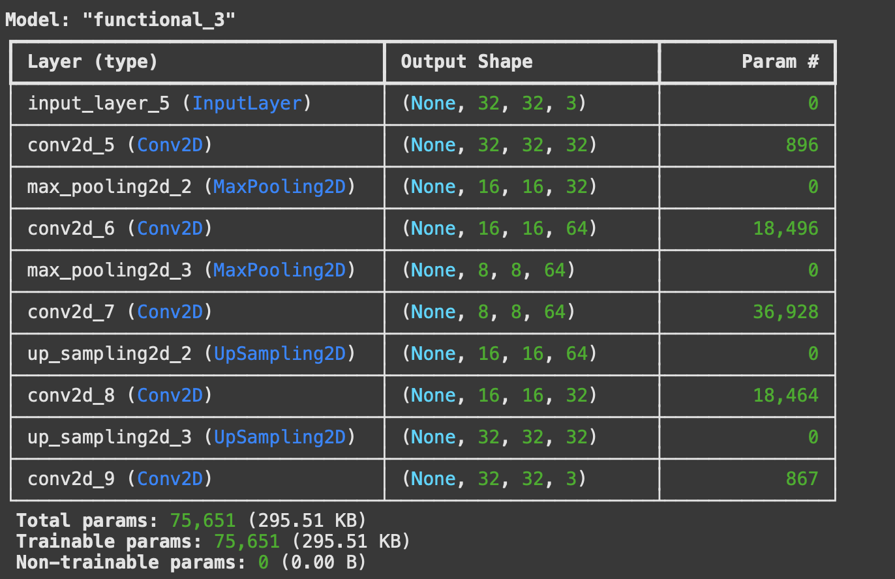

history = autoencoder.fit(
x_train_noisy, x_train,
epochs=30,
batch_size=128,
shuffle=True,
validation_data=(x_test_noisy, x_test)
)

Last 10 epochs:
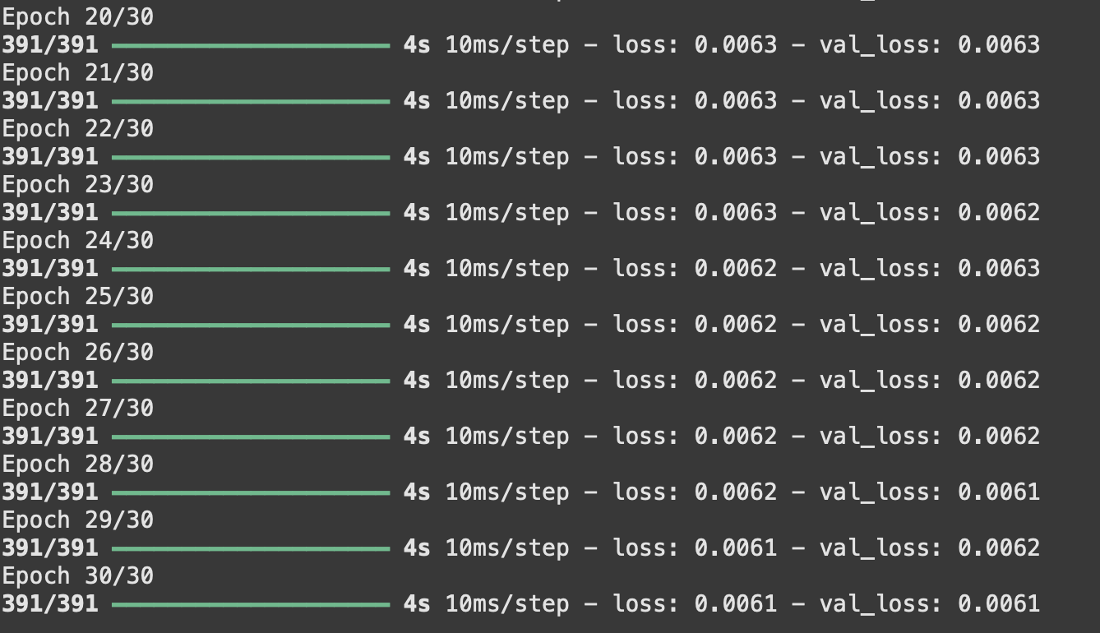
decoded_imgs = autoencoder.predict(x_test_noisy)
n = 10
plt.figure(figsize=(15, 6))
for i in range(n):

ax = plt.subplot(3, n, i + 1)
plt.imshow(x_test[i])
plt.title("Original")
plt.axis("off")

ax = plt.subplot(3, n, i + 1 + n)
plt.imshow(x_test_noisy[i])
plt.title("Noisy")
plt.axis("off")

ax = plt.subplot(3, n, i + 1 + 2*n)
plt.imshow(decoded_imgs[i])
plt.title("Denoised")
plt.axis("off")
plt.show()
